Can Teachers’ Identities Come to the Rescue in the Fourth Industrial Revolution?

Guest Speaker: Simon Bheki. Khoza
Discipline of Maths Curriculum Studies & Educational Technology, School of Education, University of KwaZulu-Natal, Durban, South Africa

Exploring teachers’ identities while teaching in the Fourth Industrial Revolution (4IR) is essential. Such assists teachers to reflect, improving their teaching through various networks. Identities are conscious thoughts interrogating subconscious thoughts that drive teachers to understand their personal needs. Eleven teachers, registered for a Master of Education degree at a university in South Africa, were purposively selected for this study. The objective of this study was to understand teachers’ identities while teaching mathematics in the 4IR. Focus-group discussions, reflective activities, and one-on-one semi-structured interviews, framed by a pragmatic case study, were used for data collection. The teachers’ identities revealed that the Three Tree Rings Theory with Currere was useful when applied as the teaching framework. Such application of the theories generated three categories of teaching identities within the 4IR. Categories were societal, professional, and personal identities. The university at which these participants were registered prescribed Moodle. However, the students mostly used social media sites such as Facebook and WhatsApp. As a result, students used digital technologies even during face-to-face classes. The study concluded that, although there were elements of both personal and professional identities, the societal identity was that which drove teaching. Consequently, this study recommends that teachers should learn to reflect on, in, and for their actions, in order to address the ‘what’, ‘how’, ‘who’, and ‘why’ questions of education, natural identity, and the 4IR/5IR.
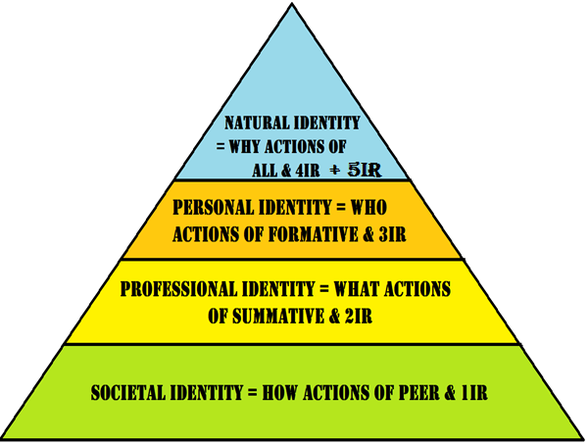
Figure ?: Framework of STEM teachers’ identities in the 4IR

Prof Simon Bheki. Khoza (PhD) is a Distinguished Teacher and Associate Professor: Maths Education and Curriculum Studies with Educational Technology at the University of KwaZulu-Natal, South Africa. He coordinates different undergraduate and postgraduate programmes, and teaches and supervises postgraduate research in Curriculum studies and Educational Technology. He has graduated more than 80 PhD/MED students and published more than 45 publications in local and international journals. His keen interest is on e-learning theories and practices. Contact details: khozas@ukzn.ac.za

